**DAFFODIL INTERNATIONAL UNIVERSITY**

**LAB REPORT - 01**

**LAB REPORT - 01**

**LAB REPORT - 01**

**Lab Report**

**Course Name:** Computer Networks

**Course Code:** CSE 313

**Report Date:** 20/02/2022

**Subject: STATIC ROUTING**

**SUBMITTED BY:**

**ARFIN SHARIAR**

I**D:**201-15-3316

**SECTION:** PC-B

**DEPARTMENT OF COMPUTER SCIENCE AND ENGINEERING**

**DAFFODIL INTERNATIONAL UNIVERSITY**

**SUBMITTED TO:**

**FATEMA TUJ JOHORA**

LECTURER (SENIOR SCALE)

**DEPARTMENT OF COMPUTER SCIENCE AND ENGINEERING**

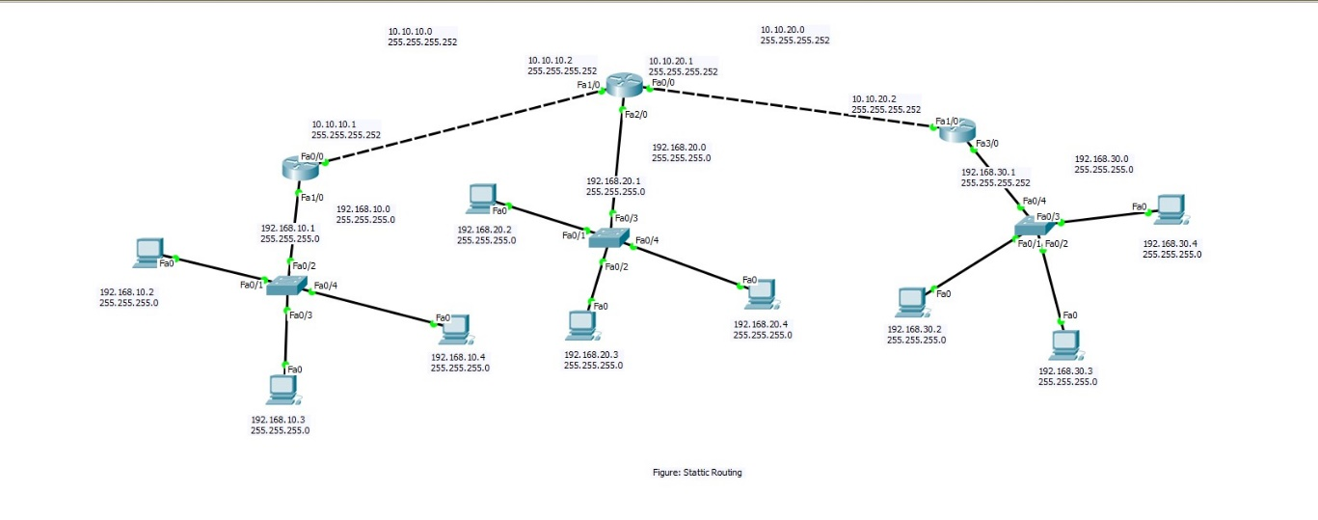

**Figure:1: Diagram for Static Routing**

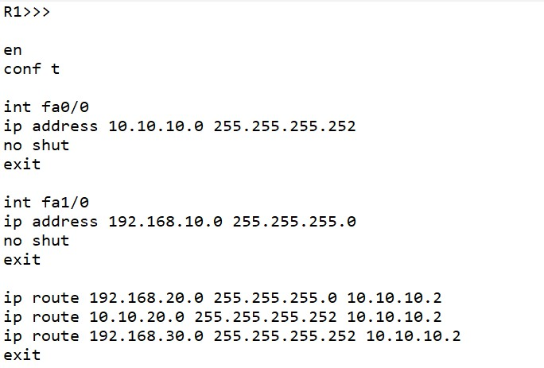

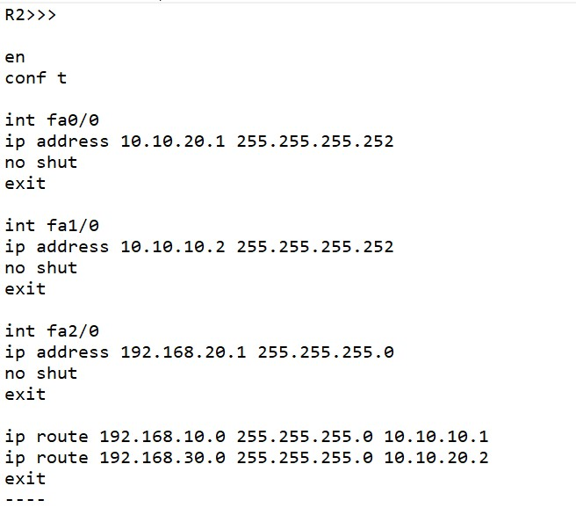

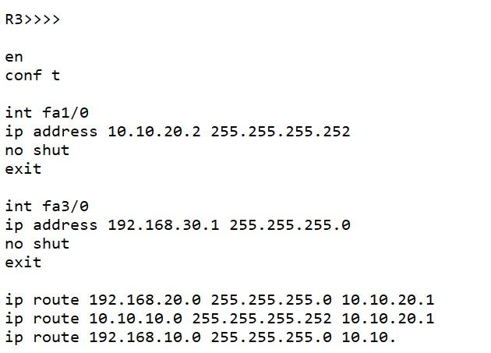

**[THE END]**